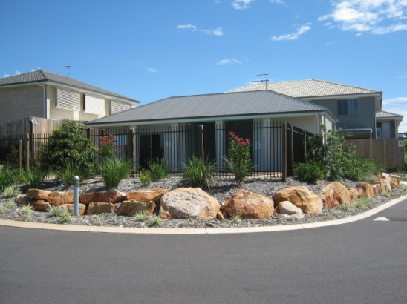
Brisbane Permanent ​Management Rights, North Lakes - Exclusive
ID﻿:010920
Net Income: $370,338
Salary: $142,797
25 years agreement with 21 Years Remaining
$2,230,000
Under Contract
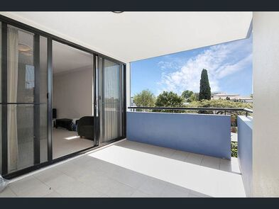
Brisbane Permanent ​Management Rights, Upper Mt Gravatt - Exclusive
ID﻿:170820
Net Income: $192,001
Salary: $79,250
25 years agreement with 22 Years Remaining
Under Contract
Brisbane Permanent ​Management Rights, West End - Exclusive
ID﻿:080620
Net Income: $285,596
Salary: $184,273
25 years agreement with 22 Years Remaining
$2,200,000
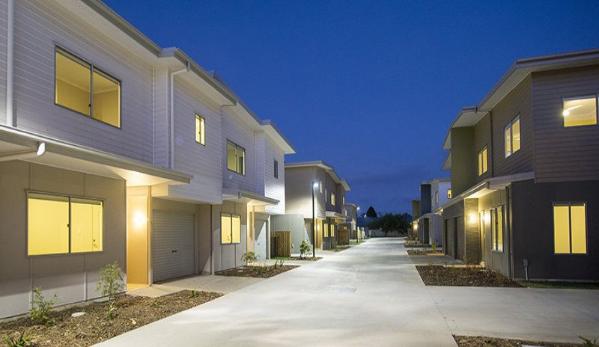
Add On Permanent Management Rights, Gladstone - Exclusive
ID﻿: 011017
Salary: $160,000
Net Income: $287,103
No Unit To Buy, Not Required To Live Onsite
Under Contract
Scan The QR Code For Our New Management Rights Listings:
Or Go To www.siremanagementrights.com.au or Call The SIRE Team 0404 331 310

